Given an array of points where points[i] = [xi, yi] represents a point on the **X-Y** plane, return *the maximum number of points that lie on the same straight line*.

**Example 1:**

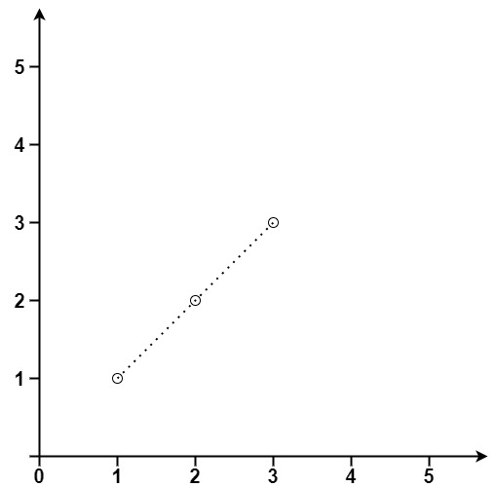

**Input:** points = [[1,1],[2,2],[3,3]]

**Output:** 3

**Example 2:**

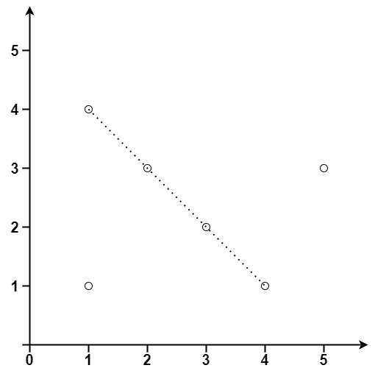

**Input:** points = [[1,1],[3,2],[5,3],[4,1],[2,3],[1,4]]

**Output:** 4

**Constraints:**

* 1 <= points.length <= 300
* points[i].length == 2
* -104 <= xi, yi <= 104
* All the points are **unique**.